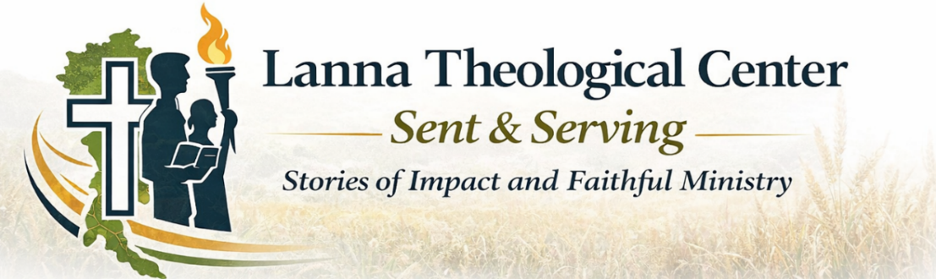


T’an’s story begins with loss.
Some of life's deepest wounds are not chosen and cannot be explained away. God does not ask us to pretend they are good. Yet He is able to enter our broken stories, bringing healing, hope, and new purpose. T'an's story reminds us that while our past shapes us, it does not have to define our future.
Her parents divorced shortly after she was born and disappeared. T’an was placed in the care of her grandparents. By the age of seven, both of her grandparents had passed. Once again, she was alone.
A local pastor knew her situation and brought her to a Christian orphanage. It was a simple act of compassion—but it changed everything. At the orphanage, T’an experienced something she had never known before: belonging.
For the first time, she felt what it meant to be part of a family—cared for, supported, and seen. It was there that she was also introduced to Jesus. As the years passed, her faith took root and grew. Along with it came a quiet but steady desire—to one day help children like herself.
But as graduation approached, uncertainty returned. Most students step into adulthood with a safety net called “home.” For orphans, that question is never so simple. Is the orphanage a forever home—or only a temporary shelter? In T’an’s case, there would be no support. Once again, she faced the unknown.
So T’an turned to the only Father who had never left her. She prayed and asked God to guide her next steps. In that season of uncertainty, she sensed His calling—to prepare herself to teach the Bible and to serve children walking the same path she once had. She
A dorm parent encouraged her to apply to Lanna Theological Center. It was a step of faith—but God provided the way with a scholarship.

T’an graduated in 2020. Today, she serves in a large dormitory for disadvantaged children. It was there that she met her husband, and together they now serve as dorm parents, providing the very thing she once longed for: a stable, loving home. Her life has come full circle.
What began as a story of abandonment has become a story of calling. And through T’an, God is now doing for others what He once did for her.

Where might God be bringing hope, healing, or purpose into your story today?
Isaiah 43:18–19 “Forget the former things; do not dwell on the past. See, I am doing a new thing! Now it springs up; do you not perceive it?”

